# Task 1

Install VirtualBox

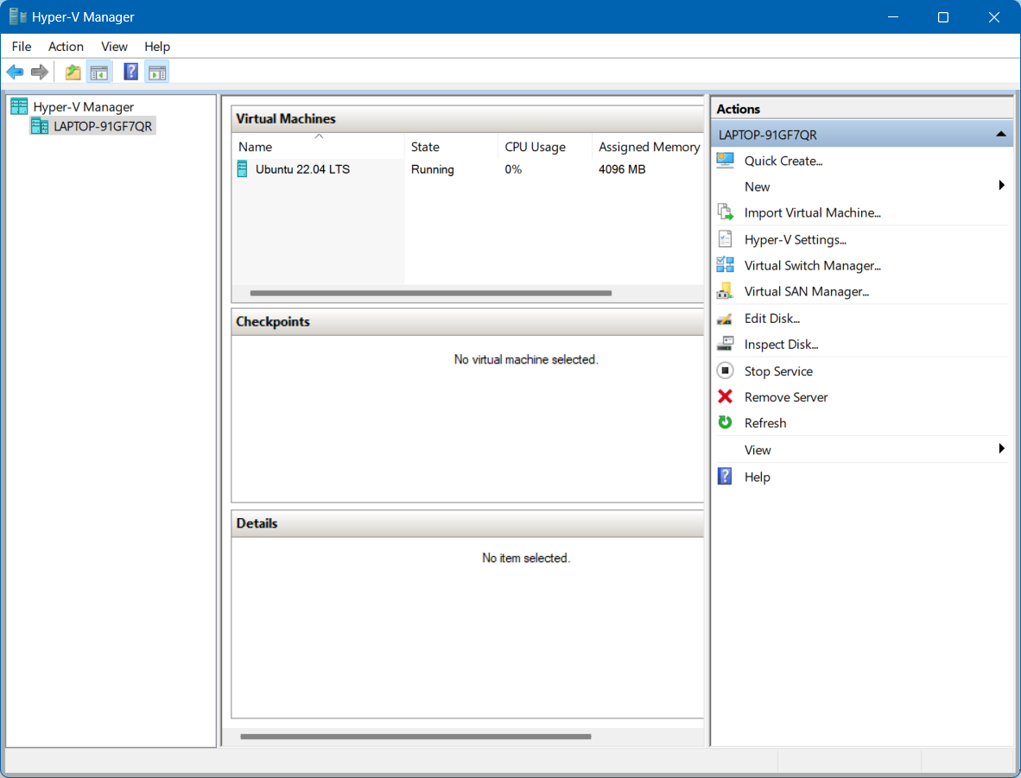

Install Ubuntu Linux

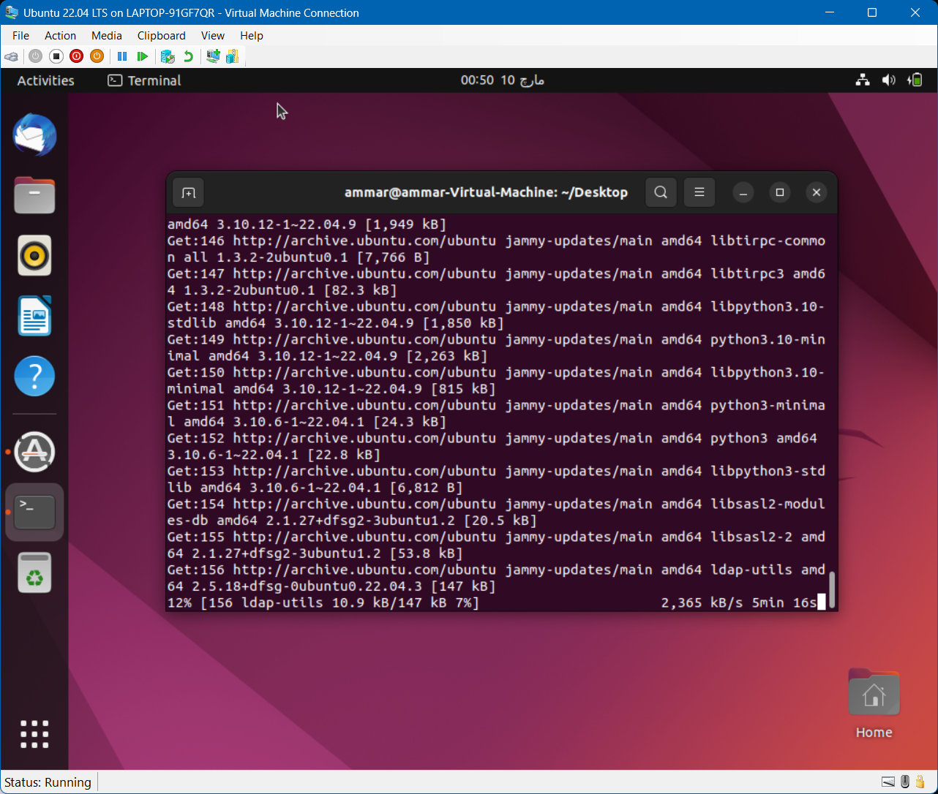

# Task 2

Setting up the development environment

node



git



Truffle



Creating a Truffle project using a Truffle Box



# Task 3

Writing the Smart Contract



Compiling and migrating the smart contract











Testing the smart contract

Testing the smart contract using Solidity





Task 4

Creating a user interface to interact with the smart contract

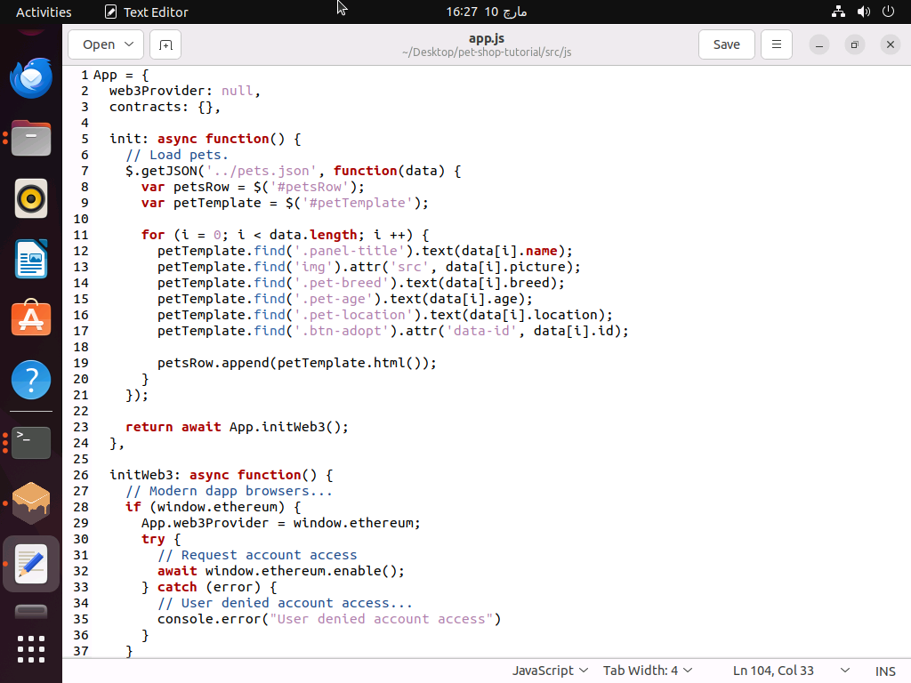

Interacting with the dapp in a browser

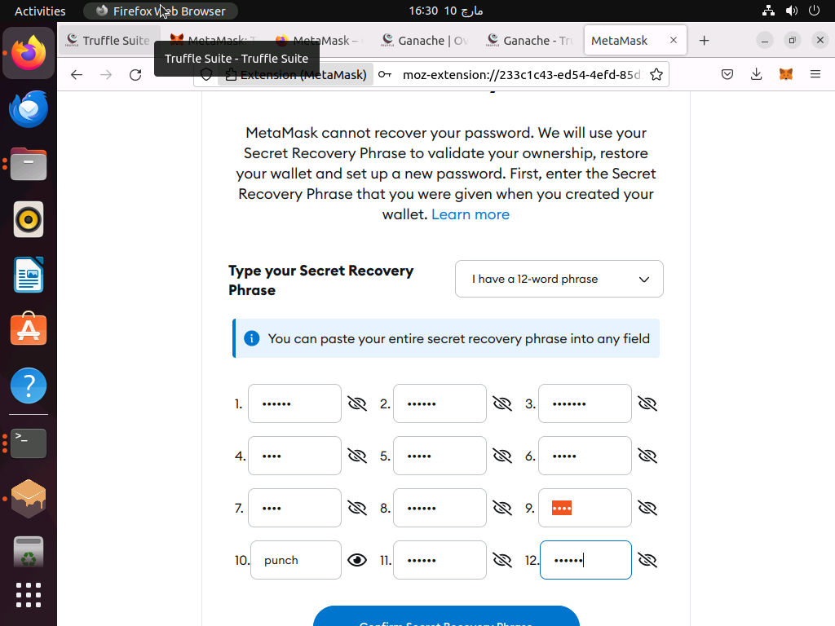

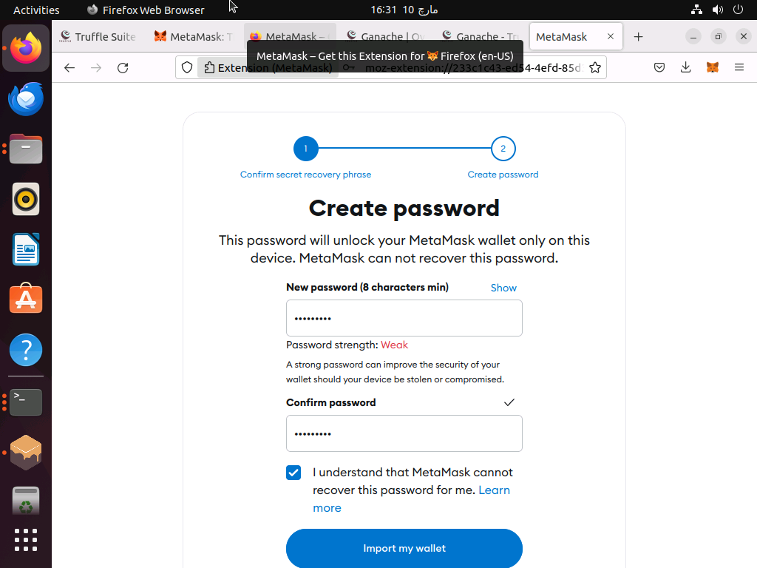

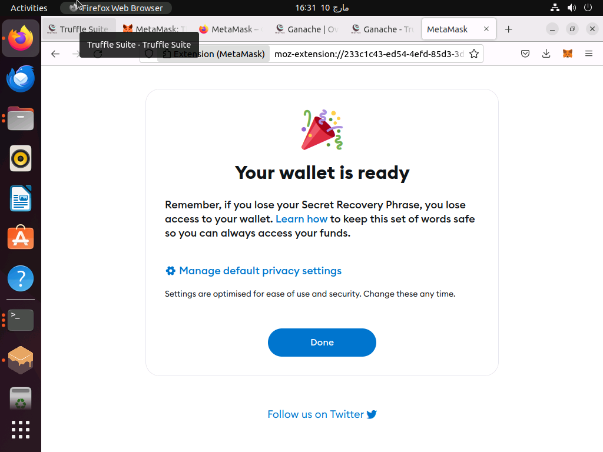

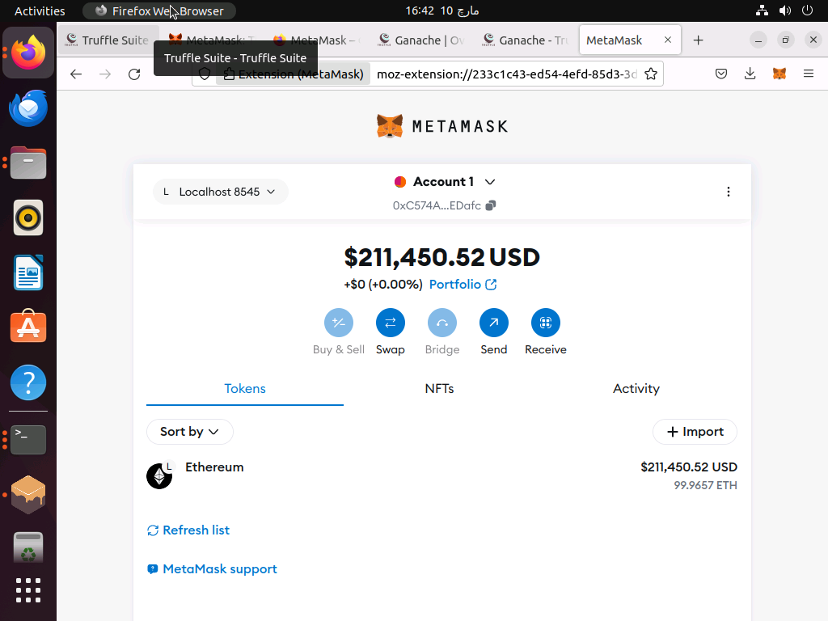

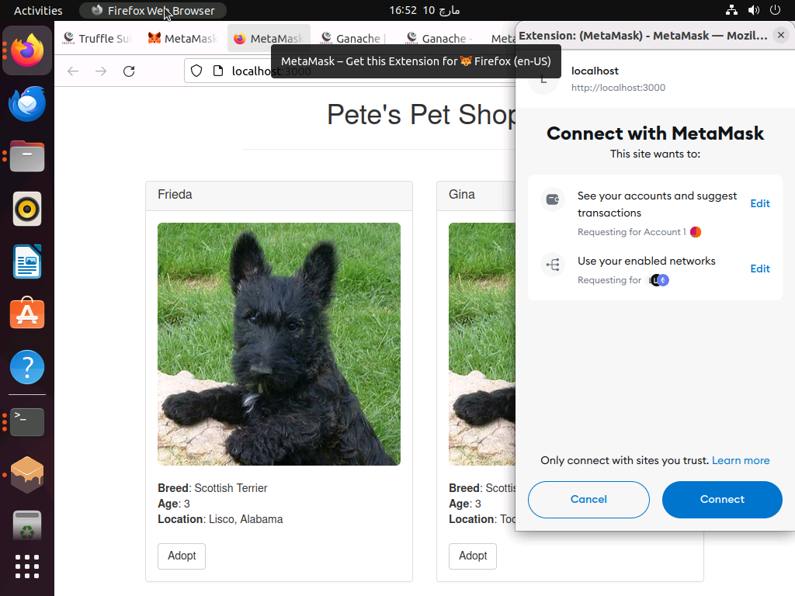

short video adopt the pet and showing the backend situation of Ethereum.

https://drive.google.com/file/d/16Irwm3veiGYb9V6OHR-FlzaEE0_Qvom5/view?usp=sharing